BROOMSTICK LACE SCARF WORKSHOP
Hooked Rug Museum of North America

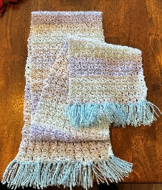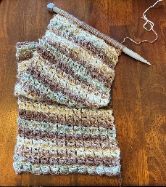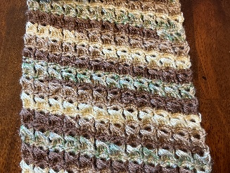

DATE: August 12, 2026 Wednesday 10:30 am - 4:30 pm

LOCATION: Hooked Rug Museum of North America (HRMNA)
9849 St. Margaret’s Bay Road, Hwy 3, Queensland, NS B0J 1T0 902-858-3060
Web: http://www.hookedrugmuseumnovascotia.org email: hookedrugmuseum@gmail.com

TEACHER: Liz Young , past teacher from the RHGNL and long term member of the Rug Hooking Guild of Nova Scotia, now permanently resides in Nova Scotia. In July 2024 she was the proud feature “Artist of the Month” at the Shoreline Gallery, Bridgewater Hospital, Bridgewater, NS. Liz is now introducing NEW Geometric Rug Hooking Workshops. She continues to teach rug hooking workshops in Canada and throughout a variety of European countries i.e. Portugal, Spain, Italy and the UK. Some of her finished pieces are for sale in the Fibre Market at the Hooked Rug Museum of North America.

WORKSHOP: When Liz was 16 years old, in the back streets of an Italian village called San Marino, an elderly Italian lady taught her the fine art of Broomstick lace making. In the workshop, you will easily learn how to create a beautiful Broomstick Lace scarf! Using a jumbo needle and a crochet hook, participants will create a 3” tension swatch to calculate the number of stitches needed to create a scarf in the length of your choice. Previous knitting or crochet experience is a definite asset. This is not knitting nor crochet, but a unique combination of both! With this lovely technique, a gorgeous shawl, a beautiful vest or a darling baby’s blanket can be created.

KIT: A kit is provided which includes detailed written instructions/pattern, jumbo needle, a crochet hook, a picture of finished sample and jumbo balls of unique Portuguese fine silky yarn in the colour of your choice.

COST: Total cost of workshop $98.00 Includes kit and registration.
A Deposit of $50.00 is required to register.

REGISTRATION: Click here to download. Print and fill in the registration form. It cannot be completed online.
Scan and email it to: hrmnaevents@gmail.com OR mail it to the Registrar at the address below.

PAYMENT (1) E-TRANSFER your deposit or payment in full to hrmnaevents@gmail.com
OR
(2) CHEQUE – Mail cheque and registration form to the address below.
OR
(3) MUSEUM – Stop into the Museum, fill out a registration form and make payment at the front counter

MAIL TO: REGISTRAR: HOOKED RUG MUSEUM of NORTH AMERICA
9849 St. Margaret’s Bay Road, Queensland, NS B0J 1T0

Confirmation of registration upon receipt of both registration form and payment

- Coffee,tea will be provided. Please bring your own lunch, snacks, cutlery and mug.
- Please do not bring anything with nuts due to severe allergy concerns.

CANCELLATION / REFUNDS: Deposit of $50.00 is refundable prior to August 1st, 2026. No refunds after August 1st, 2026.

** Any questions, please call Sherry Chandler @ 902-275-4743 or email hookedrugmuseum@gmail.com

